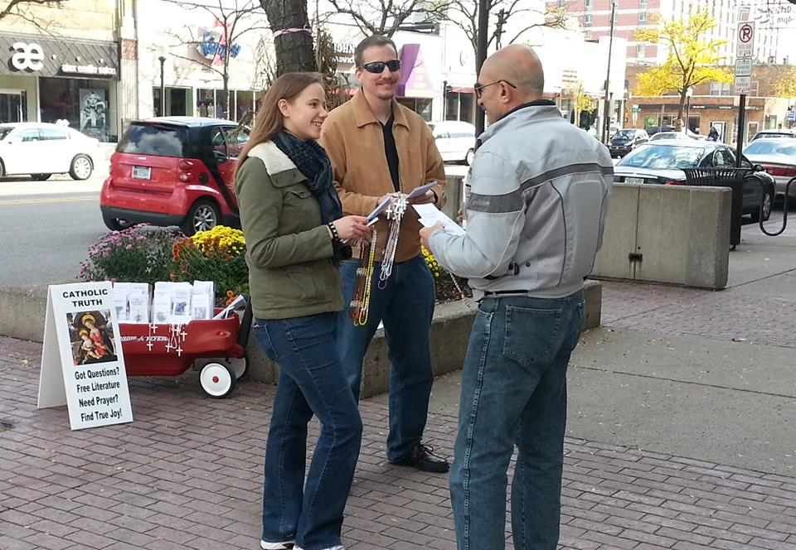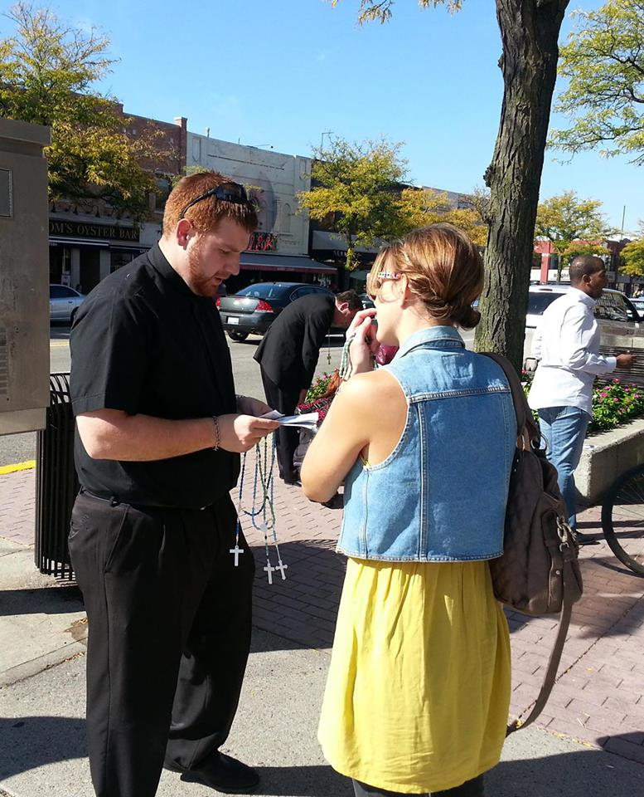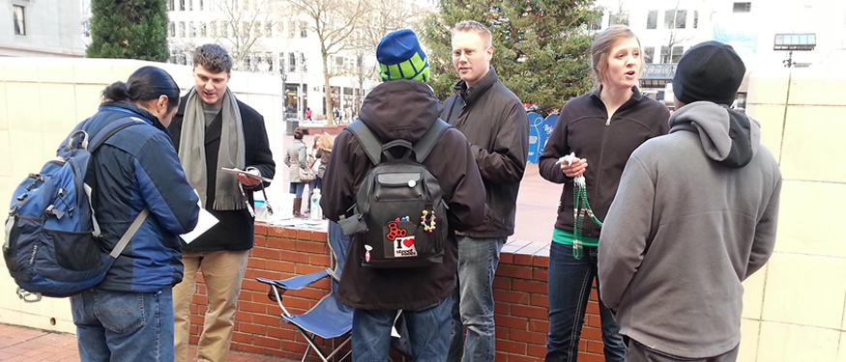 

**No Conspiracy Theories. Just Faith & Reason.**

**Contact the Lansing Team Today!**

Leader: Adam Janke

Phone: 517-455-5592

Email: adam@stpaulse.com

Website: stpaulse.com

stpaulse.com/lansing

I sense that the moment has come to commit all of the Church's energies to the New Evangelization.

Pope St. John Paul II the Great

**St. Paul Street Evangelization**